Identified Noun | Notes on including noun as a thing to store
Sales Team Member | Actor. Not stored as a domain class. Their info exists under User. Exclude.
Manager | Actor. Not stored separately; represented under User class. Exclude.
System Clock | A trigger for temporal events, not a stored entity. Exclude.
Dashboard | Yes, a key entity representing saved dashboards with refresh settings. Include.
Sales Dashboard | A specific type/view of Dashboard. Output only. Exclude.
Report | Yes, a core entity. The system generates and may store analytical reports. Include.
Custom Analytical Report | A type/instance of Report based on filters. Not a separate class. Exclude.
Daily Performance Summary | A type of generated Report (not a separate entity). Exclude.
Weekly Delivery Report | Same as above—output format of Report. Exclude.
Real-Time Data | Temporary output, shown live but not persisted. Exclude.
Filter (date range, zone, category) | Input parameters; attributes inside Report. Not a class. Research → becomes attribute.
Metric (KPI) | Derived/calculated values, not entities. Exclude.
Revenue | Derived attribute of Orders. Not a class. Exclude.
Customer | Yes, a core business entity used in segmentation analytics. Include.
Customer Segment | Yes, a grouping of customers with rules. Important for segmentation. Include.
Segment Definition / Rule | The logic behind a segment. Attribute of Segment. Research → attribute.
Customer Behavior Data | Derived analytics about customers. Not stored separately. Exclude.
Order | Yes, a foundational entity for all sales dashboards. Include.
Order Details / Order Items | Represented by OrderLine. Not a separate class. Exclude.
Order Status | Attribute of Order. Exclude.
OrderLine | Yes, required for product-level analytics (top sellers, revenue breakdown). Include.
Product | Yes, essential for all product, sales, and inventory metrics. Include.
Product Category | Optional grouping attribute of Product. Research — may or may not be modeled.
Inventory | Yes, a key data source for inventory analytics. Include.
Inventory Level | Attribute of Inventory. Exclude.
Shipment | Yes, needed for delivery performance reports. Include.
Delivery Performance Metrics | Output KPIs, calculated not stored. Exclude.
Delivery Zone | Yes, used as grouping/filter for manager reports. Include.
Zone Performance | Derived metric, not an entity. Exclude.
User | Yes, represents internal system users (sales staff, managers) who own reports/dashboards. Include.
Visualizations / Charts | Output UI elements, not stored. Exclude.
Dashboard Layout | Attribute/settings inside Dashboard. Exclude.
Snapshot / Summary Data | Derived output; if stored becomes Report. Exclude.
Time Interval | Attribute (refresh interval). Exclude.
System Event | Not stored, just a trigger. Exclude.
Triggers | Execution conditions for scheduled tasks. Not entities. Exclude.
Daily Job / Weekly Job | Process logic, not a domain entity. Exclude.

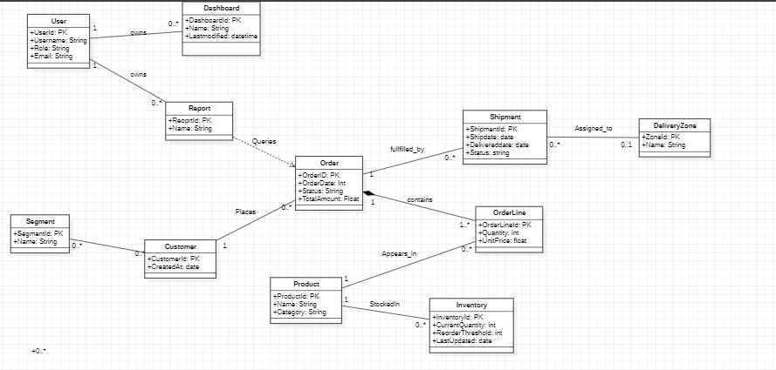

Class | Why this class is needed (short justification)
User | Represents internal users (sales staff, managers) who request reports/dashboards and own saved artifacts (saved reports, dashboards). Needed to track ownership, permissions and who created a saved item.
Dashboard | Stores persistent dashboard configurations (layout, widgets, refresh interval). Needed so users can load, refresh and share consistent analytics views.
Report | Represents ad-hoc or scheduled analytical outputs and saved report definitions. Needed to persist summary results (EOD/weekly) and saved filter configurations.
Customer | Fundamental subject of segmentation and many analytics (cohorts, LTV, region filters). Needed as the primary entity for customer-level analysis.
Segment | Stores definitions/rules for customer groups (cohorts). Needed so segmentation logic can be saved, reused and applied to dashboards/reports.
Order | Core transactional data (sales) used to compute revenue, orders count, trends and drive most analytics; read by many reports and dashboards.
OrderLine | Product-level detail within orders required for top-product metrics, revenue breakdowns and inventory movement calculations. Composition child of Order.
Product | Catalog item referenced across sales and inventory analytics (top-sellers, category filters). Needed as a dimension for most reports.
Inventory | Current stock information used by inventory reports and dashboard indicators (stock levels, reorder alerts). Needed to join with product and location data.
Shipment | Delivery events and times that feed delivery-performance metrics (transit times, success rates). Needed for weekly and EOD delivery reporting.
DeliveryZone | Geographic grouping (zones/regions) used as a filter/aggregation key in manager reports and delivery performance calculations. Needed for zone-based reporting and filtering.

